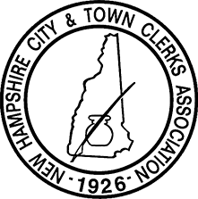
Lakes & White Mountain
Regional Workshop Agenda
Grand Summit Hotel at Attitash
Wednesday, May 28th, 2025

8:30 – 9:00 Registration
9:00 – 9:15 Welcome and introductions
9:15 – 10:30 Elections
10:30 – 12:00 Vital Records
12:00 – 1:00 Lunch
1:00 – 3:00 DMV (Registration, Title, Audit)
3:00 - 3:30 Questions

Thank you all for attending our Regional Workshop! Thanks also to our State Partners for their support as we all strive to best serve our citizens.

See you next year!

