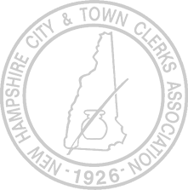
New Hampshire City and Town Clerks Association
Meeting Agenda
Wednesday, July 22, 2026, 9:30 am
NH DMV Conference Room, Concord, NH

State Partners
DMV
SOS

Executive Board
Treasurer’s Report
Secretary’s Report

Annual Conference Update
Update on the 2026 Conference progress
Logo
Committees

Dates and publicity for alternate DMV training after conference
Need to set dates and get word out ASAP

Committees
Legislative Committee
Report

Old Business
Update on Board positions and appointments

New Business

Next Meeting: Wednesday, August 19th, NH DMV Conference Room

